1)Read space-separated integers (may include negatives) from stdin on one line and print the maximum sum of any contiguous subarray (Kadane's algorithm).
include <stdio.h>
int main() {
int x, currentSum, maxSum;
if (scanf("%d", &x) != 1)
return 0;

currentSum = maxSum = x;

while (scanf("%d", &x) == 1) {
currentSum = (currentSum + x > x) ? currentSum + x : x;
if (currentSum > maxSum)
maxSum = currentSum;
}
printf("%d\n", maxSum);

return 0;
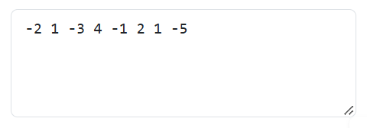

}
INPUT: OUTPUT:
2) Read space-separated integers representing the nodes of a singly linked list (in order) from stdin. Build the linked list and print the value of the middle node. If there are two middle nodes, print the second one.
#include <stdio.h>
#include <stdlib.h>

struct Node {
int data;
struct Node *next;
};

int main() {
struct Node *head = NULL, *tail = NULL, *newNode;
struct Node *slow, *fast;
int value;

// Build the linked list
while (scanf("%d", &value) == 1) {
newNode = (struct Node *)malloc(sizeof(struct Node));
newNode->data = value;
newNode->next = NULL;

if (head == NULL) {
head = newNode;
tail = newNode;
} else {
tail->next = newNode;
tail = newNode;
}
}

// Find middle node
slow = head;
fast = head;

while (fast != NULL && fast->next != NULL) {
slow = slow->next;
fast = fast->next->next;
}

if (slow != NULL)
printf("%d\n", slow->data);

return 0;
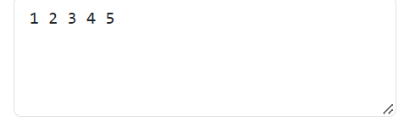

}
INPUT: OUTPUT:
3) Line 1 contains space-separated integers in sorted (non-decreasing) order, possibly with duplicates. Line 2 contains a target integer. Using binary search, print the index (0-based) of the first occurrence of the target, or -1 if it is not present.
#include <stdio.h>

int main() {
int arr[1000];
int n = 0, target;
int low, high, mid, result = -1;

// Read sorted integers from line 1
while (scanf("%d", &arr[n]) == 1) {
n++;
if (getchar() == '\n')
break;
}

// Read target from line 2
scanf("%d", &target);

low = 0;
high = n - 1;

// Binary search for first occurrence
while (low <= high) {
mid = low + (high - low) / 2;

if (arr[mid] == target) {
result = mid;
high = mid - 1; // Search further left
}
else if (arr[mid] < target) {
low = mid + 1;
}
else {
high = mid - 1;
}
}

printf("%d\n", result);

return 0;
}
INPUT:
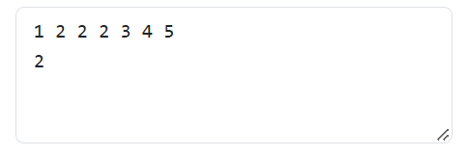
4) Read a string consisting only of the characters ( ) { } [ ] from stdin. Using a stack, print True if the brackets are balanced, otherwise print False.
#include <stdio.h>
OUTPUT :



int main() {
char str[1000];
char stack[1000];
int top = -1;
int i;

scanf("%999s", str);

for (i = 0; str[i] != '\0'; i++) {

if (str[i] == '(' || str[i] == '{' || str[i] == '[') {
stack[++top] = str[i];
}
else {
if (top == -1) {
printf("False\n");
return 0;
}

if ((str[i] == ')' && stack[top] != '(') ||
(str[i] == '}' && stack[top] != '{') ||
(str[i] == ']' && stack[top] != '[')) {

printf("False\n");
return 0;
}

top--;
}
}

if (top == -1)
printf("True\n");
else
printf("False\n");

return 0;
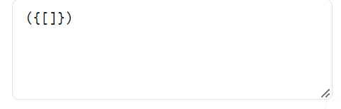
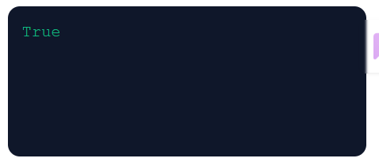
}
INPUT: OUTPUT:
5) Line 1 contains space-separated integers. Line 2 contains an integer k (window size). Using a deque (queue), print the maximum of every contiguous window of size k as space-separated values.
#include <stdio.h>

int main() {
int arr[1000];
int deque[1000];
int n = 0, k;
int front = 0, rear = -1;
int i;

// Read array from line 1
while (scanf("%d", &arr[n]) == 1) {
n++;

if (getchar() == '\n')
break;
}

// Read k from line 2
scanf("%d", &k);

for (i = 0; i < n; i++) {

// Remove elements outside the current window
while (front <= rear && deque[front] <= i - k)
front++;

// Remove smaller elements from the rear
while (front <= rear && arr[deque[rear]] <= arr[i])
rear--;

// Add current index
deque[++rear] = i;

// Print maximum when window reaches size k
if (i >= k - 1) {
printf("%d", arr[deque[front]]);

if (i < n - 1)
printf(" ");
}
}

printf("\n");

return 0;
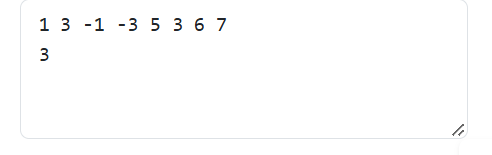
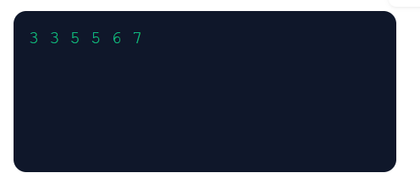
}
INPUT: OUTPUT:

